**MINI PROJECT ( MEDICAL STORE )**

**MODULE** : Sale of medicines by the user through the software.

**ASSUMPTIONS** : The following assumptions are taken into consideration for the development of this module:

* The user has already logged in.
* Medicines are available in the database

**FUNCTIONALITIES**:

* Placing order for medicine purchase.
* Display all the orders.
* Medicine sales data.
* Display medicines available in stock.

1. **Order Placement :**

* All the medicines are selected from the database using a listbox. The user selects the medicine and clicks on ‘Add’ button.

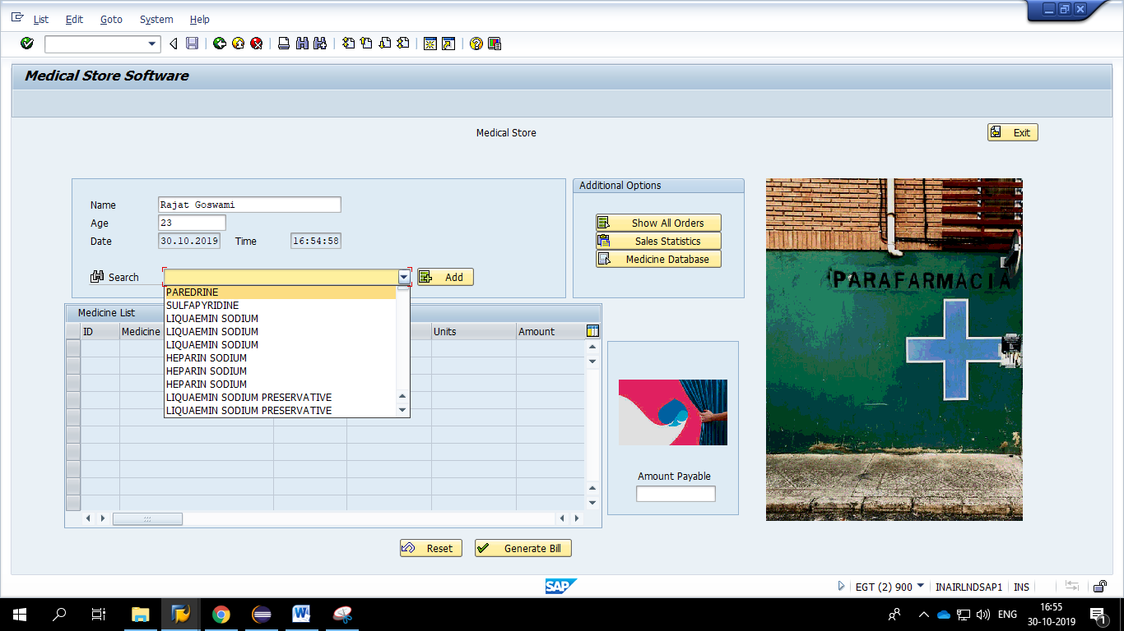

* After the ‘Add’ button is clicked a popup appears onto the screen prompting the user to enter the quantity of the selected medicines required. Enter the required number and click the check button.

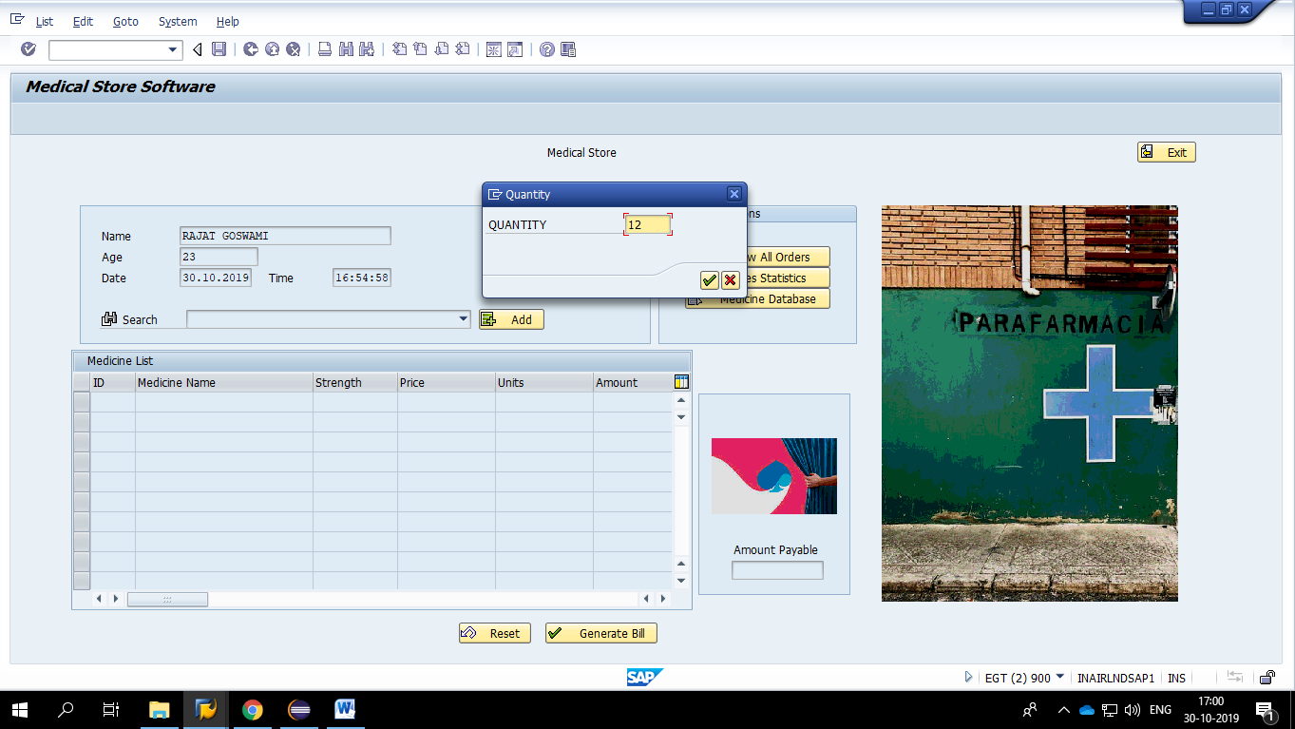

* After the check button is clicked the medicine is added as shown below.

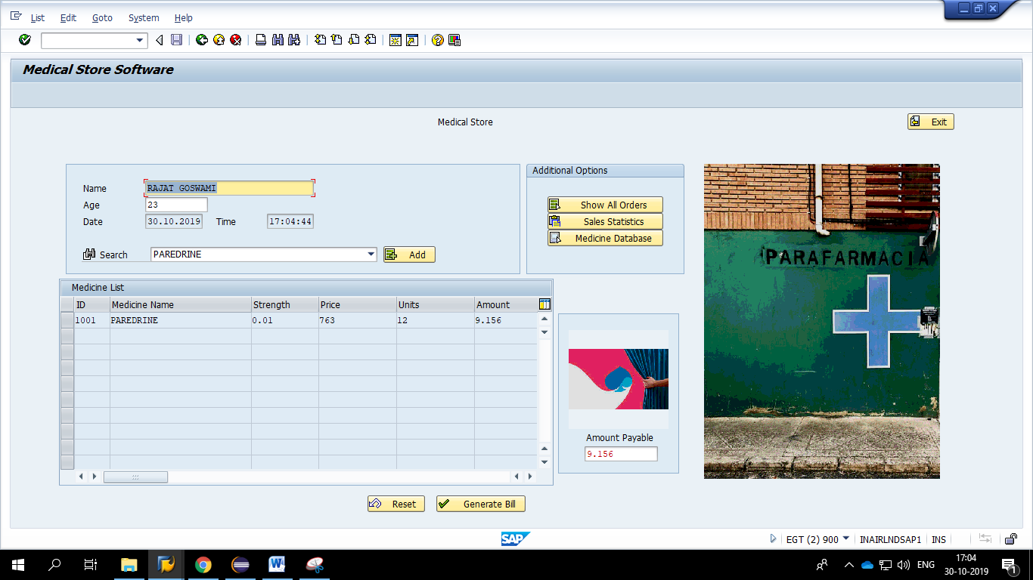

* The following validation checks are applied onto the screen:
  + No customer name

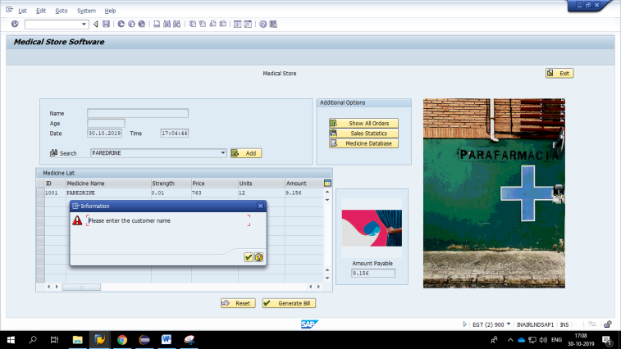

* + Customer name containing any number or symbol

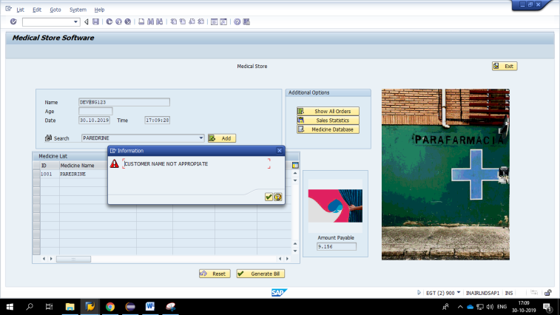

* + No quantity is given for the medicine.

1. **Display all Orders :**

The orders that are already placed are being displayed on this screen. The user can choose the month for which the orders details are required and the corresponding list is displayed inside the table control.

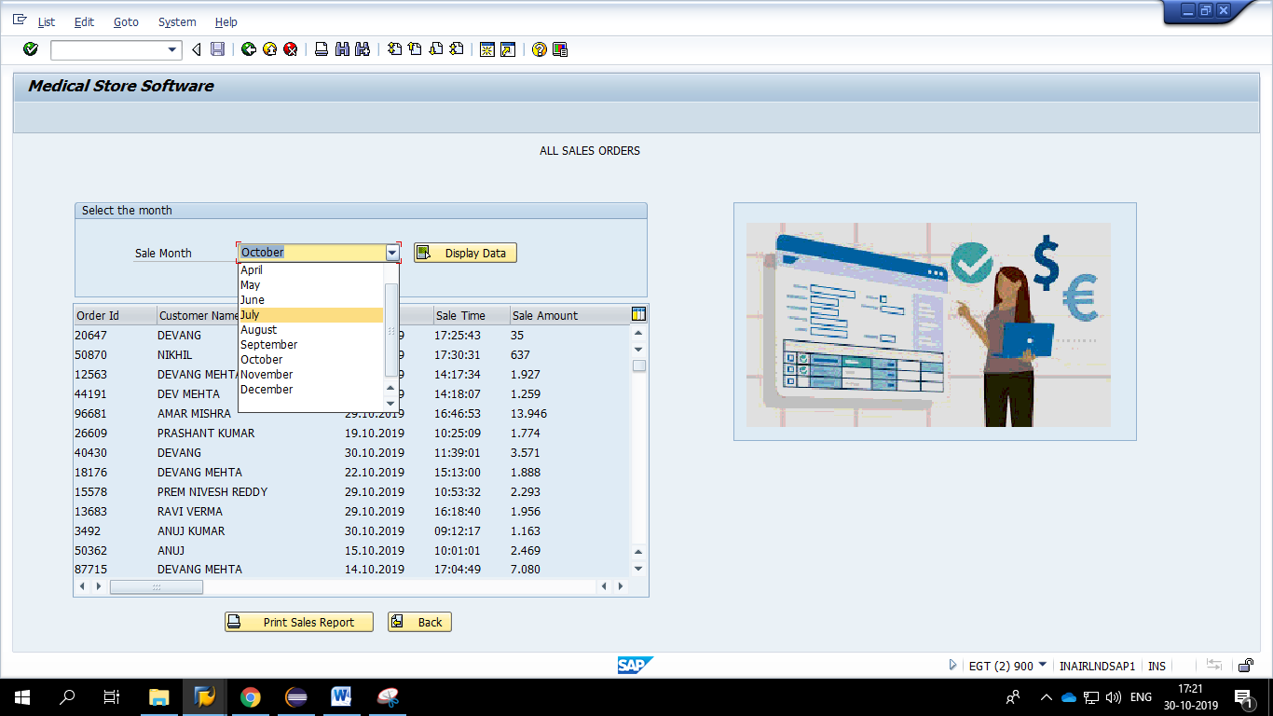

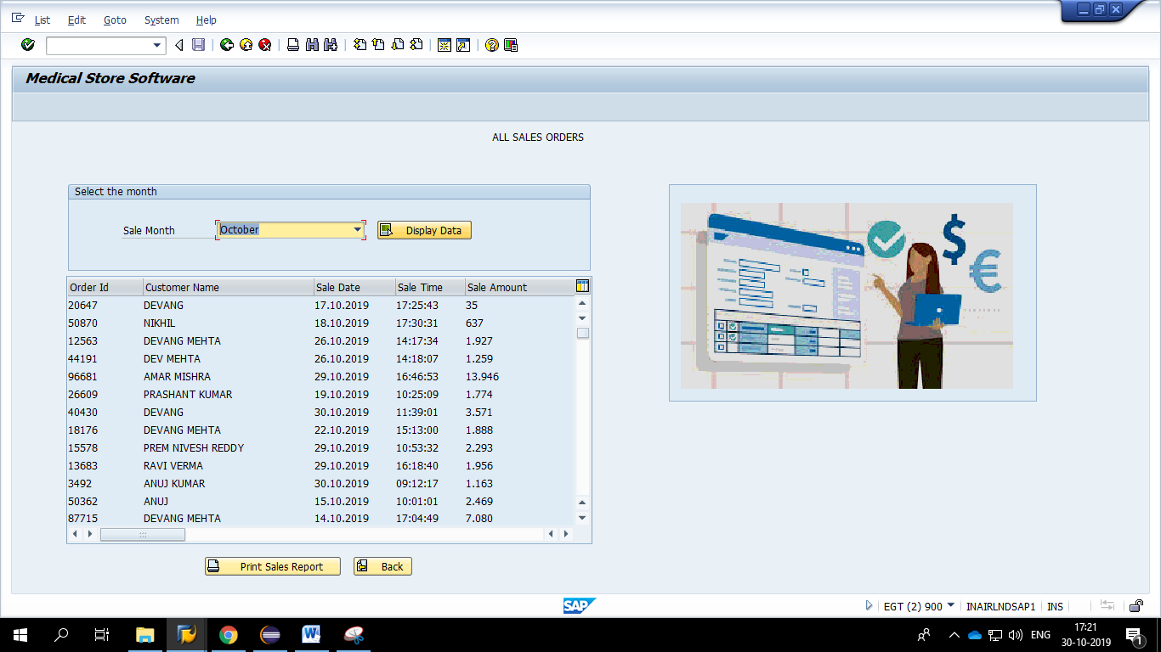

* If the user does not enter the month, the system prompts the user to enter the month as it is a required field.

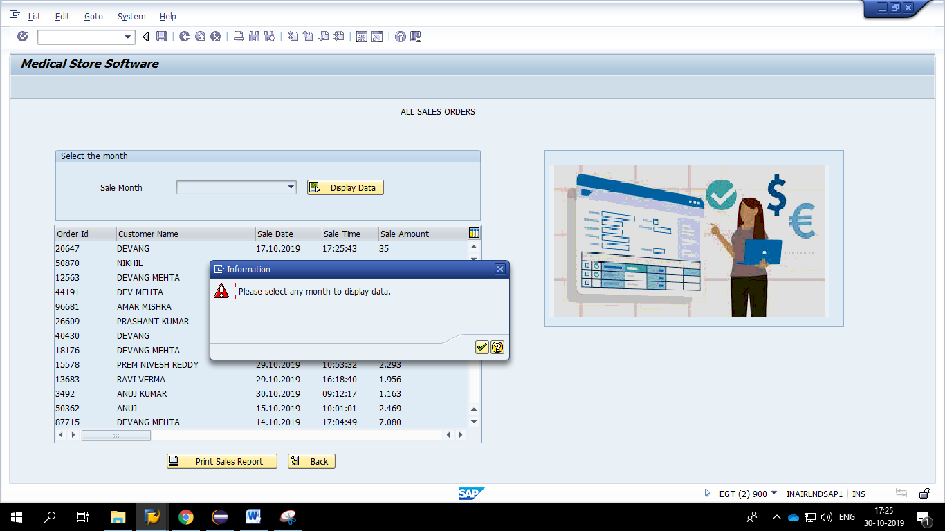

1. **Sales data of medicines :**

Here the statistical data related to the sales of medicines is displayed in the form of an alv.

The user has to provide the month for which he wants to get the medicine sales and click the ‘Display Data’ button. The result is displayed in the form of an alv.

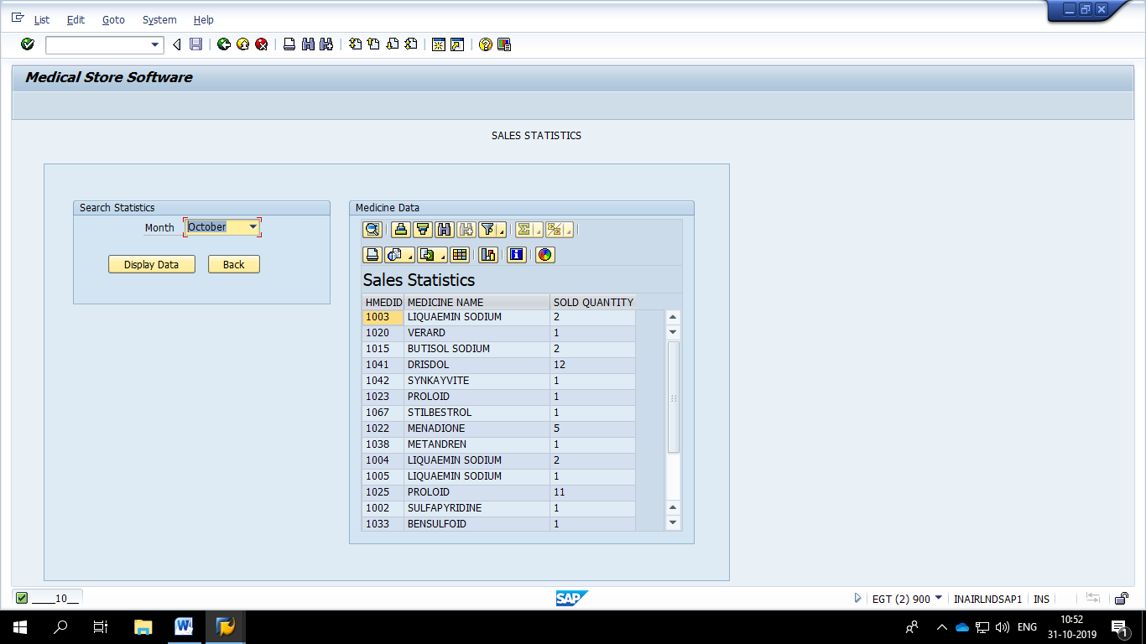

1. **Medicine Database:** This is to provide the user a functionality to view all the medicines that are available currently in the database.
   1. The medicines can be sorted according to their name or their expiry date.
   2. The user can also search for the medicine by providing prefix and clicking ‘Display Button’.

